EXPERIMENT

AIM: Design a door bell using push button.

APPARATUS: one Arduino Board, one breadboard, one BUZZER, connecting wire, resistors – 10 k Ώ, pushbutton.

CIRCUIT DIAGRAM:

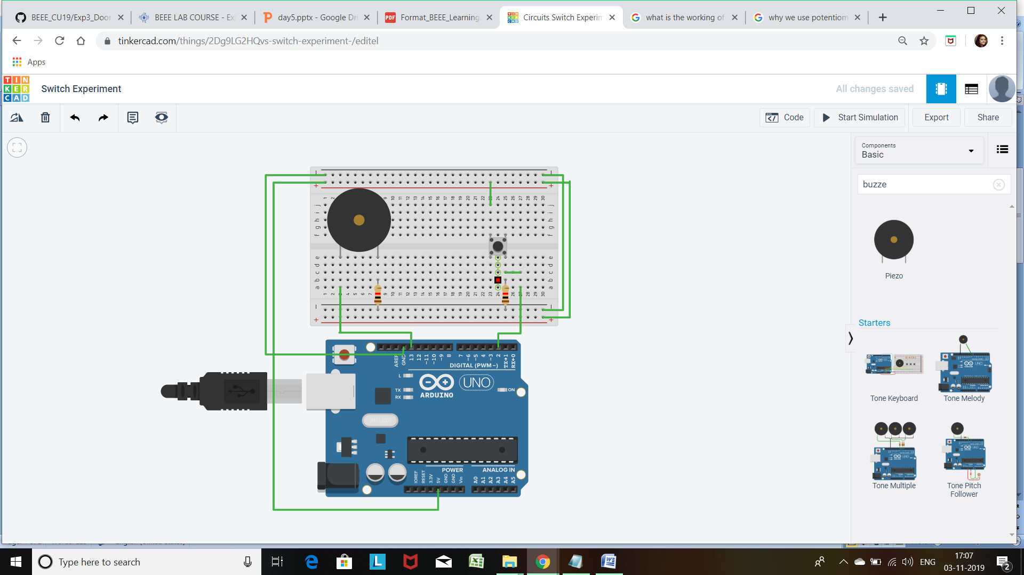

THEORY:

1. CONCEPTS USED :

* Here we have used the concepts of SWITCH.
* Connection of the SWITCH with the Arduino.

1. LEANING AND OBSERVATION:

- A **Push Button** is a type of **switch** which shorts or completes the circuit when it is pressed.

PROBLEMS AND TROUBLESHOOTING:

* Due to the wrong connection of the circuit, like the connection of the positive end of the Buzzer with the cathode terminal, the Buzzer was not working.

By observing the cathode and anode terminal the connection was corrected.

* And sometimes due to wrong insertion of pin in the Arduino board the Buzzer do not sound.
* Sometime the COM port of the Arduino creates problem. So we have checked it thoroughly for the proper connection with the computer.

PRECAUTION:

1. Checking the continuity of the current flowing through the circuit.
2. Resistance of the resistor should be correctly calculated for proper reading.
3. Buzzer should properly work.

LEARNING OUTCOMES

By doing this experiment we learned to control a buzzer.

RESULT

As a result of these, when we press the switch the buzzer start to make sound and when we remove or release it the buzzer turns off.